SCIENTIFIC EVIDENCE IN SUPPORT OF UNITED NATIONS EASTBOURNE
MVULE PROJECT FOR CARBON CAPTURE

Sections:
- Mvule’s highly efficient carbon capture
- Beneficial companion planting with Mvule
B1. Maesopsis eminii
B2. Terminalia superba
- Biomass calculations & carbon capture
- Above ground biomass & stem rot
- Importance of tropical tree planting
- Climate related scientific evidence relevant to Uganda
- Evaluation of tree projects for carbon sequestration

- THE SCIENTIFIC EVIDENCE FOR MVULE’S HIGHLY EFFICIENT CARBON CAPTURE
In recent years considerable research has been conducted on the special oxalogenic properties of Milicia excelsa (known in East Africa as mvule and West Africa as iroko). The carbonate-oxalate pathway of this tree species has proved to be a newly identified and neglected carbon sink. Below are key research papers amongst the increasing number of scientific studies on the special role of Mvule as an efficient agent for long-term carbon storage.
Sources:
- Braissant, Olivier, et al. 2004. Biologically induced mineralization in the tree Milicia excelsa (Moraceae): its causes and consequences to the environment. Geobiology 2(1) DOI: 10.1111/J.1472-4677.2004.00019.x University of Neuchâtel, Institutes of Geology and Botany. (Note: In recent years considerable research has been conducted on the special oxalogenic properties of Milicia excelsa known in East Africa as mvule and West Africa as iroko. The carbonate-oxalate pathway of this tree species has proved to be a newly identified and neglected carbon sink).
“(The) abundance of carbonate minerals within M. excelsa testifies to the fact that the inorganic sink is of great significance to the terrestrial carbon cycle… the sustainability of a carbon pool is also an important point: time residence for organic matter and mineral carbon in soil are at least 10¹-10³ years and 10²-10⁶ years, respectively. Biologically induced mineral carbon sinks are undoubtedly more efficient for carbon sequestration than soil organic matter”.

In terms of rate of carbon capture the following calculations are given for an 80 year old tree, bearing in mind that M.excelsa trees over 200 years old have been located. “.. calculations using soil and tree carbonate titrations suggest at least 1500 kg of C_{mineral} is trapped during the life of a single M.excelsa tree (c.500kg inside the tree and c.1000kg in surrounding soils). This value is equivalent to a sequestration of 18.25 kgC yr⁻¹.” (Note: lifespan here is taken as 80 years whereas Milicia excelsa can grow for over 250 years and continues to sequester carbon exceeding 3.5 tonnes C_{mineral} for very mature trees).
(NB Update by Ian Elgie. Personal communication with Dr. G. Cailleau 3/10/2019. A re-evaluation of the data through C14 dating of age of trees has reduced C_{mineral} rates of capture to 160kg for tree and 460kg for soil for 80 yr. old tree. The new total of 620kg C_{mineral} would equate to a carbon capture rate of 2.273 tonnes CO² per tree over 80 yrs. from inorganic carbon alone). Note: this could be a low figure as over 1 tonne of mineral carbon (= 3.664 tonnes CO2) has been found in the stump and soil around an Mvule tree of 80 years in age (see ref. 2 below).

- Guillaume Cailleau, Olivier Braissant & Eric P. Verrecchia. 2004. Biomineralization in plants as a long-term carbon sink Naturwissenschaften 91: 191-194. “Carbon sequestration in the global carbon cycle is almost always attributed to organic carbon storage alone, while soil mineral carbon is generally neglected. However, due to the longer residence time of mineral carbon in soils (104–106 years), if stored in large quantities it represents a potentially more efficient sink…. The system is considered as a net carbon sink because carbonate accumulation involves only atmospheric CO2 and Ca from Ca-carbonate-free sources. Around one ton of mineral carbon was found in and around an 80-year-old iroko stump, proving the existence of a mineral carbon sink related to the iroko ecosystem. Conservation of iroko trees and the many other biomineralizing plant species is crucial to the maintenance of this mineral carbon sink.
- Cailleau, G., Braissant O., & Verrecchia E.P. 2011. Turning sunlight into stone: the oxalate-carbonate pathway in a tropical tree ecosystem. Biogeosciences 8:1755-1767. (Doi:10.5194/bg-8-1755 2011). The research suggests that the iroko ecosystem can act as a long-term carbon sink, as long as the calcium source is related to non-carbonate rocks. Consequently, this carbon sink, driven by the oxalate carbonate pathway around an iroko tree, constitutes a true carbon trapping ecosystem. Details also given of the role of termites, saprophytic fungi and bacteria in breaking down the decaying plant tissues further adding to the carbon sink.
- Cailleau, G., et al. 2014.Detection of active oxalate-carbonate pathway ecosystems in the Amazon Basin: Global implications of a natural potential C sink. Catena. Vol 116, May 2014, pp.132-141. Comments on the oxalate-carbonate pathway (OCP) as being widespread in the plant world and, therefore a potential important source of C sink in Amazonia. However, indications are that carbonate accumulated under African Milicia ecosystems is 3 to 4 times greater than in Amazonian soils.
- Ferro, Katia Imeria. 2012. The impact of oxalogenic plants on soil carbon dynamics – formation of a millennium carbon storage as calcium carbonate. Univ. of Neuchâtel. Dr. Sc Thesis.
(Note: Dr. Ferro indicates in her study that earlier researchers/authors “have found that this oxalogenic tree-soil system runs like a pump, driving carbon from the atmosphere to the hydrosphere through the pedosphere and, therefore, inscribes it in the global carbon cycle.”
Her research provides details of the carbonate-oxalate pathway in M.excelsa and the following observations:
p116. “Although the maximum lifetime of a M. excelsa tree is unknown, trees of about 250 years are frequently cited or studied in the Central African Republic”.
“Normally, M. excelsa stumps remain in place after the tree is cut, as a result of deforestation and wood trade. Their biodegradation is difficult, due to the intrinsic properties of lignin and the high carbonate content of wood, which makes it practically impenetrable to normal chainsaws. Nevertheless, termites are able to grind M. excelsa stumps allowing the release of oxalate and carbonate into the soil environment.”

p119. “Chemical changes in soils due to the oxalate - carbonate pathway indicate a pH increase and an accumulation of alkaline cations (Ca and Mg), which can improve soil fertility. Consequently, plantations of biomineralizing plants would not only enhance CO₂ retention and capture in soils but also increase agronomical productivity.”

Section 1.7.4 p15.
“Regarding the rapid increase of the atmosphere and the potential problems due to the greenhouse effect caused by this gas, the challenge is now to slow down the CO₂ in the air. There are two different ways: reduction of emissions and looking for stocks. The M. excelsa system is a natural pump for atmospheric CO₂ allowing the formation of the oxalate- carbonate pathway with the result of a long-term carbon stock in soil in the form of carbonate”.

- Pons, S. et al. 2018 Biocontrolled soil nutrient distribution under the influence of an oxalogenic-oxalotrophic ecosystem. Plant and Soil, Vol.452, Issue 1-2, pp.145-160. (Note: refers to the usefulness of the Milicia excelsa in increasing the nutrient value of soils to benefit agroforestry and in this study Coffea arabica).
- J.A. Ugwu and A.A. Omoloye, 2015. Perception on the Constraints to Propagation of Iroko (Milicia excelsa) (WELW) C.C. BERG in South West Nigeria. Research Journal of Forestry, 9: 48-5 DOI: 10.3923/rjf.2015.48.57
Notes that “Despite the potential of M. excelsa, there is little or no propagation of this plant and the regeneration from the wild cannot commensurate (sic) the demand for Milicia timber in Africa. International Union for Conservation of Nature (IUCN) has placed Milicia in their red list as endangered species.”
9. Luc Durrieude de Madron. 2003. Diametrique du bele de l’Iroko. Bois et Forets des Tripiques no. 275 (1). The article has several charts on the annual growth of Milicia excelsa.

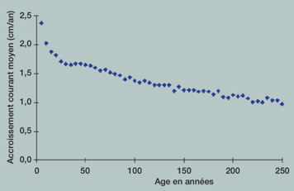
Figure 1.
Mean diameter growth cm/yr. of 46 Iroko (Mvule) trees by age in years.
Notes:
- Even with very old trees (>250yrs) substantial growth is maintained.
- Trees can reach 50m in height and 2.5m diameter.
- In the timber trade minimum exploitable diameter (MED) is 80cm for Iroko (reached on average in 130 years.

(IDE note: See survey below on Biomass Calculations by Onefeli, A.O.et al. (2012)).

- Aragno M., Verrecchia E. (2012) The Oxalate-Carbonate Pathway: A Reliable Sink for Atmospheric CO₂ Through Calcium Carbonate Biomineralization in Ferralitic Tropical Soils In: Satyanarayana T., Johri B., Anil Prakash (eds) Microorganisms in Environmental Management. Springer, Dordrecht. Abstract: “Calcium carbonate has a residence time in soils in the order of 10^{4–6} years. Therefore, sequestration of atmospheric carbon as CaCO₃ is almost irreversible, as compared to organic carbon. Calcium oxalate, a metabolite often accumulated in plants, is chemically highly stable. However, it is readily oxidized by oxalotrophic bacteria, with simultaneous alkalinisation and biomineralization of calcium carbonate, which eventually accumulates in soil. In tropical countries, on mainly acidic, non-calcareous soils, this represents a significant sink for atmospheric CO₂: at the present rate of increase, one full-grown Iroko tree may stabilize concentration of CO₂ in the air column above a 2,400 m² surface. This process may be applied in reforestation and agroforestry, as well as in conservation and sustainable development of tropical forests and soils.
(Note: In 2005 Dr. Cailleau et al. first observed large accumulations of limestone in African ferralitic soils under certain tree species, particularly the Iroko tree. In such soils, the pH under the tree was distinctly alkaline, reaching values between 8 and 9, whereas the soil at a distance was acidic with values <6.
- For general comprehensive notes on Milicia excelsa visit website: https://uses.plantnet-project.org/en/Milicia_excelsa_(PROTA)

- SCIENTIFIC EVIDENCE ON BENEFITS OF COMPANION PLANTNG with M. excelsa
The papers below indicate the physiology, biomass and carbon capture potential of the two key companion species identified for planting with Mvule. Scientific studies on the status of Terminalia superba as an oxalogenic tree is still awaiting although other Terminalia in the genus have been identified as oxalogenic e.g. T.bellirica and T.oblonga.
B1. Maesopsis eminii (Musizi)
General: Indigenous tropical tree, fast growing light-demanding pioneer species, semi-deciduous (deciduous under severe drought), density 370-480 kg/m⁻³; dbh @ maturity 50-180cm; height @ maturity 40m, branch ageing (self-pruning) 10-35m, unbuttressed, lateral & deep tap root, shade intolerant from one year.
- Buchhholz T. et al. (2004). Maesopsis eminii - a challenging timber tree species in Uganda - a production model for commercial forestry and smallholders. Paper presented at a IUFRO conference, Lugo, Spain.15p. This technical specification explores the carbon sequestration potential of Maesopsis and benefits to farmers. In woodlots described rotations are 12-20 years for timber, with high quality fuel wood harvesting in early years. Some farmers are using Maesopsis for provision of shade under coffee and banana land use systems. It has long been established that shade coffee yields better and is of superior quality than the conventional un-shaded coffee. Other products and services from Maesopsis woodlots include fodder (fruits), support to honey production, and restoration of positive environmental and ecological functioning in heavily degraded areas. Such functions include: runoff and soil erosion control, micro- climatic modifications, and increased terrestrial biodiversity (e.g. birds).

Table 1: Maesopsis growth in its optimum range.
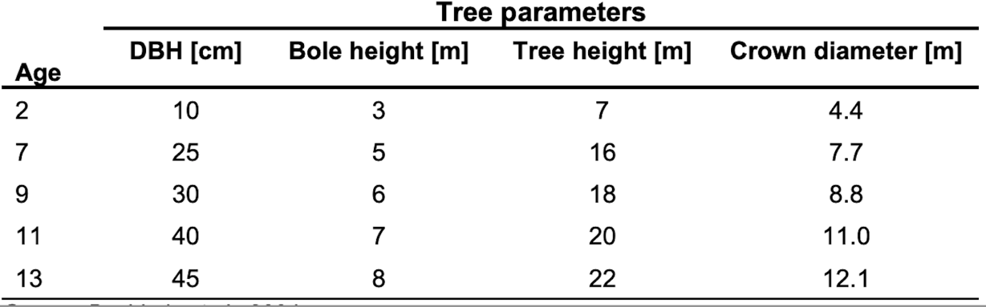

Figure 2 carbon accumulation under sole M.eminii woodlots.
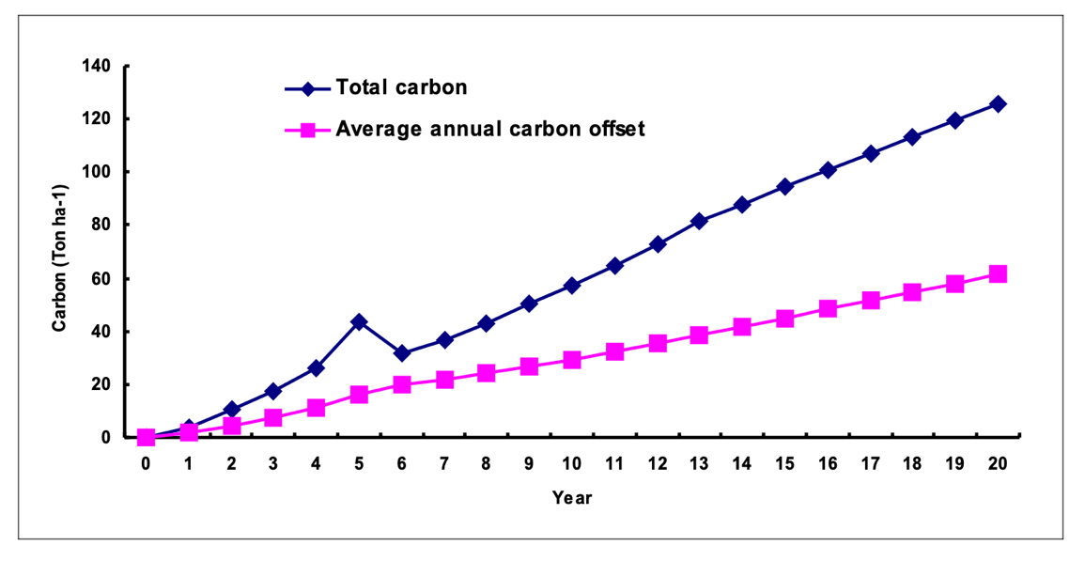
The above graph is for a plot of 50 Maesopsis eminii trees after thinning. The graph indicates at 20yrs 120 tonnes carbon sequestered by 50 trees after thinning. (IDE: This equates roughly to 2.4 t/C/per tree = 8.8 t/C02/per tree at 20 yrs.
- Buchholz t. et al. (2010). Modelling heliotropic tree growth in hardwood tree species – A case study of Maesopsis eminii. Forest Ecology. V260, 10, pp 1656-1663. Emphasises the genetic feature of strong apical dominance which results in fast straight bole development relative to branches. Useful growth data for 285 sampled trees of known ages 1.5yrs to 38 yrs by dbh and height.
M.eminii Growth Rates (adapted from Table 1, p.1658).
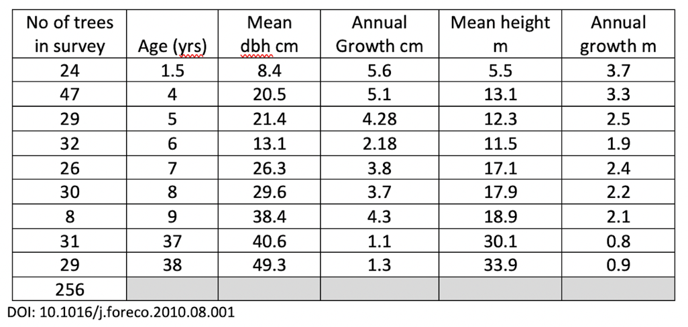
- Epila, J. (2016). Ecophysiological assessment of drought vulnerability of the African tropical tree species Maesopsis eminii Engl.. PhD Thesis, Ghent University, Belgium. ISBN-number: 978-90-5989-958-2. The study investigated the drought coping strategies and mechanisms of the African pioneer semi-deciduous tree species Maesopsis eminii. The species was chosen because of its economic and ecological importance in tropical Africa. It is used as timber, for crop shade, to limit erosion, as medicine, as medium for mushroom culture, as source of edible oil, as a road-side ornament and as firewood and fodder and in general for enrichment planting. Deciduous, light demanding species are considered to be able to better cope with forecasts of increasing drought stress in tropical Africa with climate change.
- Epila, Jackie, et al. (2017) The ecology of Maesopsis eminii Engl. in tropical Africa African Journal of Ecology DOI: 10.1111/aje.12408. Comments on the functional traits allowing M. eminii to grow under a wide range of site conditions, having both deep taproots and an intricate mat of lateral roots that permeate the subsoil, allowing the species to explore resources (nutrients and water) from both shallow and deep soil layers supporting its fast-growing and competitive habit.
- Telli-Nelson, et al. (2008). Tree growth and management in Ugandan agroforestry systems: effects of root pruning on tree growth and crop yield. Tree Physiology, v.28, Issue 2, Feb.2008. Pp 233-242. https://doi.org/10.1093/treephys/28.2.233 (IDE comment: useful data on root pruning of M.eminii to assist under-canopy crops, with little effect on overall growth of tree).
- Okorio, J., et al. Comparative performance of seventeen upperstorey tree species associated with crops in the highlands of Uganda. Agroforest Syst 26, 185–203 (1994). https://doi.org/10.1007/BF00711210 (IDE comment: Trials were established at three sites in Uganda to test the suitability of multipurpose trees (MPTs) as upperstorey in crop lands to provide poles, small timber and fuelwood. M.eminii (with average growth rates of 1.8-2.7m annually) showed an average of 60% decline in understory crop yields without root pruning. But with root pruning crop yields increased by up to 52%.

B2: Terminalia superba (Limba).
  - Maitre, Henri-Felix and Don Wijewardana. 2004. Conservation and Provenance Plantings and Integrated Pest Management to Sustain Iroko Production in West Africa (Ghana). ITTO PROJECT PD 3/95 Rev.2 (F). (Note: useful information on difficulties in establishing Milicia plantations due to control of Phytolyma lata, cf. community plantings. Sapling spacing of 4m x 4m with mix of Terminalia superba has been found to give good results.
  - Bosu, Paul P. et al. 2006. Survival and growth of mixed plantations of Milicia excelsa and Terminalia superba 9 years after planting in Ghana. Forest Ecology and Management 233 (2-3): 352-357. DOI: 10.1016/j.foreco.2006.05.032. “Iroko (Milicia excelsa and M. regia) is a valuable hardwood from the humid tropics of Africa and, is currently under threat of extinction because of over-exploitation and poor regeneration. Attempts to establish Milicia plantations in Africa have been hampered by gall-forming psyllids of the genus Phytolyma. This study investigated the impact of Phytolyma on Milicia planted in 11:89, 25:75, 50:50, and 100:0% mixtures (by stem numbers) of M. excelsa (high-risk species) and Terminalia superba (companion species). At the forest site, M. excelsa survival was 10% in the short season plantation and 30% in the long season plantation. Mean diameter and mean height were significantly higher in the long season plantation than in the short season plantation 2.4 cm versus 0.43 cm diameter respectively, and 295 cm versus 74 cm in height. However, neither survival nor growth was influenced by density of Milicia in a plot. Survival of Milicia was even lower (6.3%) at the agricultural site (short season only). Survival and growth of T. superba were relatively higher than that of M. excelsa. The mean overall diameter growth of T. superba was significantly higher at the agricultural site than at the forest site. Shade from T. superba appeared to reduce psyllid galls on M. excelsa, though crop tree growth was slow, with the best mean height attained being 400 cm at 8–9 years in 50:50 mixtures. Continuing experiments will involve thinning and-or pruning T. superba so that low levels of galls and reasonably rapid growth of M. excelsa will be achieved. (Note: 4m x 4m spacing proved successful in other studies). (IDE Comment:
- On companion planting. Given the scientific evidence, together with the local favourable conditions in eastern Uganda, the UNA Eastbourne, has within the Mvule Project for Carbon Capture, the goal of planting equal number of seedlings of the species Terminalia superba and Maesopsis eminii. Both these fast-growing trees grow well with M. excelsa and are popular with communities to meet short-term and medium-term fuelwood and timber needs.
- On Phytolyma lata (gall) infestations. Ian Elgie’s (IDE) field observations in Sironko district Uganda November 2019, support the view that although not a cause of significant mortality, infection can reduce main stem height. Evidence (also supported by the NFA Mbale) suggests that infected seedlings will suffer slower growth rates and changes in stem morphology but can recover within a few years (sample: 4 adjacent Mvule which after 7 years the only gall infected Mvule was 47% shorter than fastest growing Mvule). It can be further noted that historically Phytolyma lata has been identified as a continuing problem for M.excelsa commercial plantings throughout tropical Africa. IDE suggests that the large merchantable stem from natural forests which are not so typical in deforested areas, where shorter stem size to bifurcation point, is due to the relative absence of gall fly in these closed canopy forests.
  - De Ridder, Maaike et al. (2010) The potential of plantations of Terminalia superba Engl. & Diels for wood and biomass production (Mayombe Forest, Democratic Republic of Congo. Ann.For.Sc.67, 501. DOI: 10.1051/forest/2010003. Main survey was of limba (T.superba) trees 50-58yrs old. Buttress height N=2365 trees (72% of buttresses higher than dbh. Mean DAB (Diameter Above Buttress 202.5cm.) Buttress height increases with age of tree. 23yr old limba reached DAB of c37cm (indicating fast early growth). Bole height (N= 265 trees) mean 25.2m. Total tree height (N=128 trees) mean 31.5m Note: mean ratio Bole Height: Total Tree Height = 0.78: 1.0 indicating some 80% of trunk has commercial value. Mean AGB 4.1-4.4 tonnes/tree. After Groulez & Wood (1984) 14-18yr had bole heights of 17-21m (growth rate of 0.8 to 1.2m/y⁻¹). High natural self-pruning capacity giving high % of valuable stem timber. Small branches & leaves c.3% of total AGB. Note: limba has small crown as percentage of AGB cf. other species, i.e., about 20% in young trees declining to 9-11% in older limba.
  - De Ridder, M. et al. In the heart of the limba tree (Terminalia superba Engl. & Diels): detection methods for heart rot and false heartwood. (nd). Older trees may suffer from hollowing and brittle heart (limba noir). (IDE Comment: The UNA Eastbourne Mvule Project plants T. superba as a medium rotation tree 16-20 yrs for timber well before heart rot will occur).

- SCIENTIFIC REFERENCES ON BIOMASS CALCULATIONS & CARBON CONTENT
- Charve, J. et al. (2005). Tree allometry and improved estimation of carbon stocks and balance in tropical forests. Oecologia 2005, Vol.145, Issue 1, pp87-99. Detailed consideration of interspecific variation and the adaptive significance of wood C content of AGB. Suggested that for tropical hardwoods in natural forests, a mean biomass-C conversion factor of 47.4% is currently the most reliable, analytically supported value for wood C content (revising the IPCC conversion factor of 49%). Mentions the lack of detailed studies on below ground biomass (BGB) and carbon, which is generally estimated to be 24-37% of AGB.
- Charve, J. et al. (2014). Improved allometric models to estimate above ground biomass in tropical trees. Global Change Biology (2014) doi: 10.1111/gcb.12629. Paper analysed a global database of harvested trees at 58 sites, spanning a wide range of climatic conditions and vegetation types. When studies using trunk diameter, total tree height and wood specific gravity were included in the AGB (above ground biomass) model as covariates, a single model was found to hold across tropical vegetation types. Wood specific gravity was an important predictor of AGB. Several allometric models discussed, with model 4 as the most appropriate if tree height, DBH and wood density available. Mentions that in many allometric models tree height has been absent as in closed canopy forests it is difficult to measure accurately.
- Henry, M., et al. (2011). Estimating tree biomass of sub-Saharan African forests: a review of available allometric equations. Silva Fennica 45(3B): 477–569. This study contains a comprehensive database of allometric equations for SSA. The various equations found in the database reflect the variability in volume and biomass of different ecological zones, tree species, ages, management types and sites found in SSA. This work highlights important gaps in researchers’ ability to use equations for estimating biomass and C stocks in the various ecological zones and countries found in SSA. The use of species-specific biomass equations, rather than volume and generalised equations, are encouraged. The equations reported different tree compartments, including the stem wood and bark, stump, thin and gross branches, leaves and roots. Because it is difficult to measure the volume of the leaves or thin branches, the volume equations did not consider all of the tree compartments but focused on the bole and the merchantable compartments. Merchantable volume excluded non- merchantable aboveground compartments such as treetops, branches, twigs, foliage, stumps (sometimes excluded) and roots. On the other hand, biomass equations often considered more compartments that have fodder (leaves) or firewood (twigs) purposes.
- Onefeli, A.O. et al. (2012). Volume Prediction for Milicia excelsa trees in Selected Institutions in Ibadan, Oyo State, Nigeria. Agric.Sci. Env. 2012, 12(1):26-28. The study identifies majority of M. excelsa trees (61 sampled) in city of Ibadan are on institutional grounds as they have been protected from felling. The study showed that stem volume of M. excelsa can be predicted from db and dbh by using the equation given with reasonable precision. Of the 61 trees 26.2% were distributed in the 105.1 to 130cm class, 24.6% in the 130.1 to 155cm class with few in the extreme diameter class. The majority of the trees (73%) were in the diameter range 105.1 to 180cm. 3.3% were in diameter class 205.1 and above, with one specimen having a dbh of 382cm and db of 430cm and 41m THT and MHT of 21m. Below extract from Table 3 Summary of Statistics of growth variables p30.
Variable | Mean | Minimum | Maximum (61 Iroko trees )/ Milicia excelsa
SV (m³) | 16.59 | 0.14 | 66.36 (Stem Volume)
dA (m²) | 1.68 | 0.05 | 11.46 (Basal Area)
dbh (cm) | 137.95 | 24.00 | 382.00 (Diameter breast height 1.3m)
THT (m) | 27.22 | 9.00 | 41.00 Total Tree Height
MHT (m) | 14.94 | 4.00 | 22.00 Merchantable Tree Height (ie.to bifurcation)
dm (cm) | 96.59 | 20.00 | 180.00 Diameter middle (mid-stem)
dt (cm) | 79.08 | 10.00 | 160.00 Diameter top (top of main stem)
(IDE comment. One mvule specimen in Ibadan was recorded with a dbh of 3.82m which is exceptional and indicates a longevity of hundreds of years).
- Sinacore, K. et al. (2017) Unearthing the hidden world of roots: Root biomass and architecture differ among species within the same guild. PloS one vol. 12,10 e0185934. 12 Oct. 2017, doi:10.1371/journal.pone.0185934. Species differences in foliar biomass ranged from 6-14% of total tree biomass; branch biomass allocation ranged from 27-40%; stem biomass ranged from 20-41%. An average of 26.7% of total biomass was allocated to roots (excluding fine roots). Ref. is made to other studies (eg. Vogt et al – see below) which suggest fine roots can account for a significant amount of total biomass: 8%, 1-2% and 7-14% of total biomass for broadleaf deciduous, broadleaf semi-deciduous and broadleaf evergreen tropical trees. See Fig 4 below for biomass fraction with tree components.
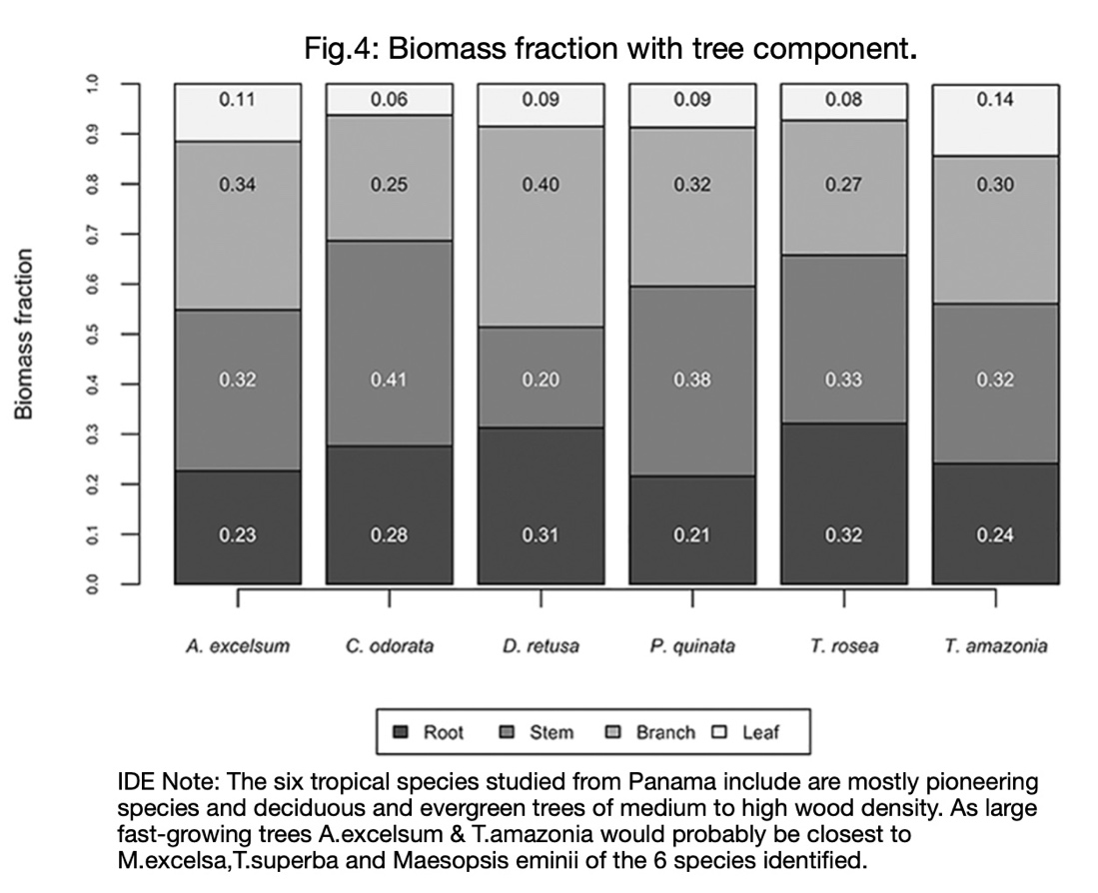
- Waring BG, Powers JS. (2017). Overlooking what is underground: root:shoot ratios and coarse root allometric equations for tropical forests. Forest Ecology and Management 385: 10-15. DOI: 10.1016/j.foreco.2015.11.007. Details the efforts to determine the ratio between BGB of coarse roots to the AGB of leaves, branches and stems (shoots). Considerable range in R:S ratios with average of 0.53, concluding that BGB of coarse root stocks in tropical forests can exceed AGB, with older trees generally having higher R:S ratios.
- Vogt, Kristiina A. et al (1996). Review of root dynamics in forest ecosystems by climate, climatic forest types and species. Plant and Soil 187: 159-219. Comments on fine roots (dia <2mm) which generally contribute <2% of total biomass (TB). However, in broadleaf tropical forests fine roots varied from 1-8% of TB and roots from 7-34% of TB. (Table 1).
- ABOVE GROUND BIOMASS & STEM ROT

Numerous scientific papers all point to the overestimation of Above Ground Biomass (AGB) (>9%) and therefore efficiency of carbon capture of a wide variety of tree species in a variety of biomes. Stem rot or hollowing is caused by fungal, termite attack and fire. Rotting trees are returning CO2 back to the atmosphere. Some species of trees can be more susceptible. Surveys show % of trees affected by hollowing is considerable eg. 65% (Marra 2019); 66-89% (Royal Society 2014); 54% (Heinnemann 2015). Hollowing generally increases with age of tree – as measured by the dbh. (See Fig 5. below from Nogueira 2006), Important to emphasise the Milicia excelsa even with dbh > 200cm rarely shows hollowing due to its high resistance to fungal decay and termite attack. Companion species T.superba and M.eminii planted under the Mvule Project for Carbon Capture also are relatively free of hollowing).

- Marra, Robert E. et al. (2019) Tomography: An Innovative Technique for Assessing Forest Carbon Storage. Earth & Environment, Engineering & Tech.
Tree damage caused by wood-decaying fungi means that forests store less carbon than previously thought. As forests play a vital role in sequestering atmospheric carbon, knowing the extent of hollowing has important implications in the fight against climate change. Using the pioneering non-invasive sonic tomography a survey of common hardwood trees in USA showed 65% of trees had hollowing with as much as 36.7% of the stem hollow.
- Royal Society (2014) Why are so many trees hollow? Royal Society Biology Letters. 1 Nov 2014. https://doi.org/10.1098/rsbl.0555. The paper discusses two hypotheses to explain the widespread extent of hollowing. Surveys of savannah woodland in Australia have found hollow cores (a phenomenon called piping) in 66–89% of trees of different species; on average, hollow cores extended to 50% of the total diameter. A study in the Amazonian rainforest found 37% of trees from a broad range of species to be piped. The paper also mentioned that trees with large lateral branches need a solid stem to compensate for the stress on the trunk and would therefore not be expected to have hollow stems. (IDE comment: This is the situation with M.excelsa – a tree with large heavy branches which has no hollowing, although the common oak with relatively large lateral branches does suffer hollowing).
- Heinemann, K.D. et al. (2015) Evaluation of stem rot in 339 Bornean tree species: implications of size, taxonomy, and soil-related variation for aboveground biomass estimates. Biogeosciences, 8 Oct. 2015, 12, 5735–5751, 2015 https://doi.org/10.5194/bg-12-5735-2015 Survey of stem rot of sample of 3180 trees of 339 species in Borneo showed that on average AGB was reduced by 7% on account of stem rot. % of stem rot increased with DBH but not necessarily severity. 13% of sample had stem rot at 10-30cm DBH and 54% at >50cm DBH.

- Brigitte, Aya et al. (2014). The dynamics of hollowing in annually burnt savanna trees and its effect on adult tree mortality. Plant Ecology. Jan. 2014 v.215, Issue 1, pp.27-37. Findings: For species resistant to hollowing, tree mortality was rare; alternatively, for species prone to hollowing, whole trees died quickly and before the most severe hollow classes could be observed.
- Nogueira, Euler Melo et al. (2006). Volume and biomass of trees in central Amazonia: influence of irregularly shaped and hollow trunks. Forest Ecology & Management. v. 227, issues 1-2, 15 May 2006 pp. 14-21. https://doi:10:1016/j.foreco.2006.02.004 Findings: From survey of large number of trees in Amazonia sampled in each class based on the diameter distribution of a large inventory. For large trees (DBH ≥50 cm) total basal area was overestimated by 30%. (IDE comment: M.excelsa has a straight bole with little or no buttressing- so basal overestimation would be at a minimum for this species of tree. Note too, the table below (Fig.5) which shows how most species as the get older (greater dbh), have substantially increased % of hollowing.
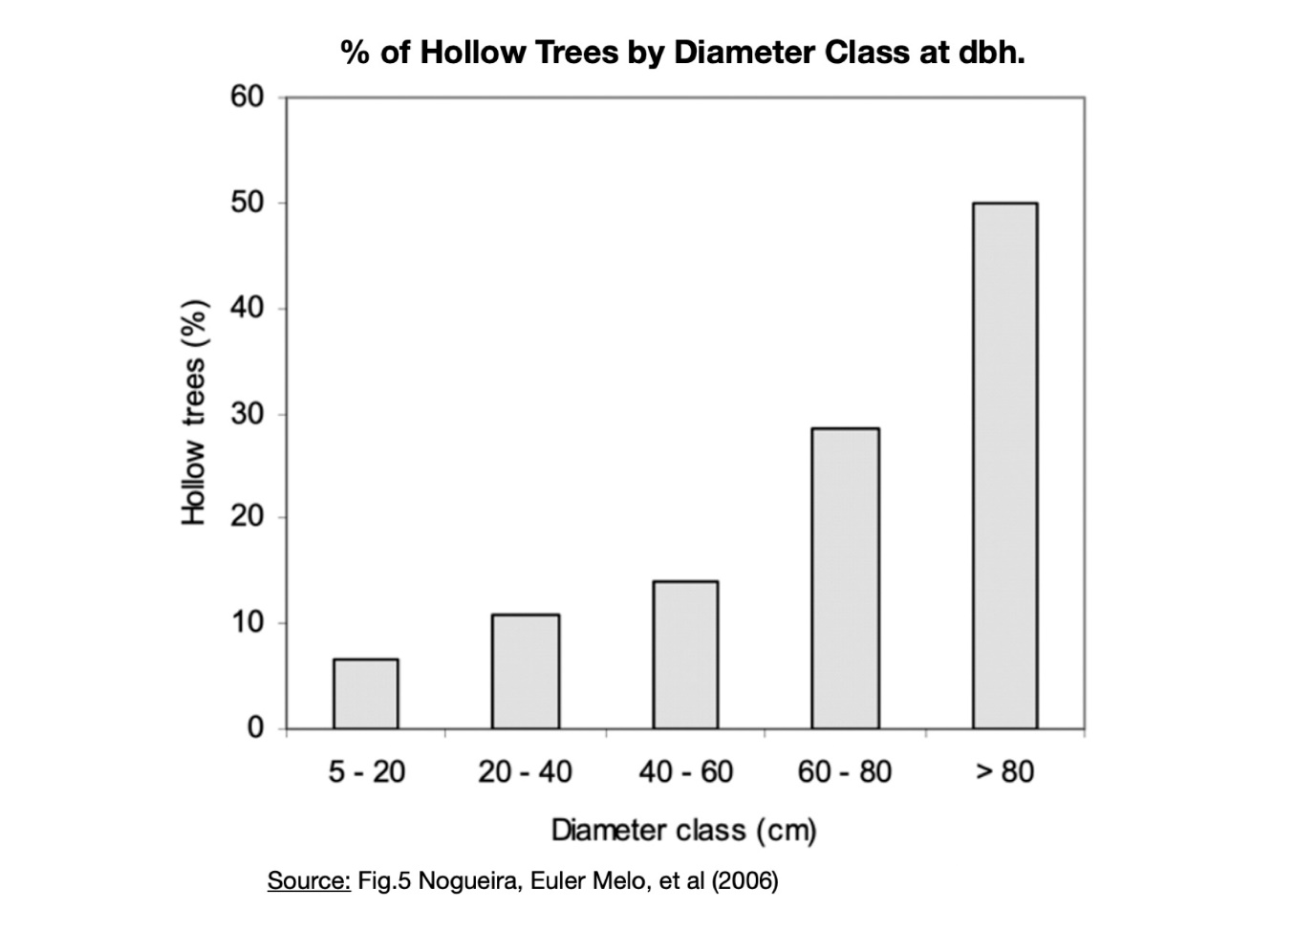
- SCIENTIFIC PAPERS ON THE IMPORTANCE OF TROPICAL TREE PLANTING
- Bastin, Jean-Francois et al. (2019). The global tree restoration potential. Science July 2019,365 (6448): 76-79. DOI:10.1126/science.aax0848. Photosynthetic carbon capture by trees is likely to be among the most effective strategies to limit the rise of CO₂ concentrations across the globe. Consequently, a number of international initiatives [such as the Bonn Challenge, the related AFR100, and the New York Declaration on Forests (4, 5)] have established ambitious targets to promote forest conservation, afforestation, and restoration at a global scale. The latest special report by the Intergovernmental Panel on Climate Change (IPCC) suggests that an increase of 1 billion ha of forest will be necessary to limit global warming to 1.5°C by 2050. The study estimates that if we cannot deviate from the current trajectory, the global potential canopy cover may shrink by ~223 million hectares by 2050, with the vast majority of losses occurring in the tropics.
- IPCC (2019) Climate Change and Land. (Draft proposal). Detailed analysis with confidence levels indicated for all performances. Eg. Section A4.5 p12. “Where forest cover increases in tropical regions cooling results from enhanced evapotranspiration (high confidence). Increased evapotranspiration can result in cooler days during the growing season (high confidence) and can reduce the amplitude of heat related events (medium confidence). In regions with seasonal snow cover, such as boreal and some temperate, increased tree and shrub cover also has a wintertime warming influence due to reduced surface albedo28 (high confidence).”
- Brienen, R.J.W. et al. (2020). Forest carbon sink neutralized by pervasive growth-lifespan trade-offs. Nature Communications 11, 4241 (2020), https://doi.org/10.1038/s41467-020-17966-z.
Paper provides firm evidence for the existence of a universal trade-off between early growth and tree lifespan in trees with the potential to reduce, or even reverse the global carbon sink of forests in the future. Faster growth has a direct and negative effect on tree lifespan. Growth increases across high latitude and tropical forests are expected to reduce tree lifespans and may explain observed increases in tree mortality in these biomes. Shorter lifespans will mean the benefits of these faster-growing forests might also be short-lived as forests die off sooner and end up storing less carbon. Moreover, when trees die, they slowly begin to release their carbon stores in the form of methane, a potent long-lived greenhouse gas. (IDE comment: This observation is less critical for the two companion species planted under the Mvule Project for Carbon Capture (T.superba and M.eminii), as they are generally harvested well before maturity whilst the Mvule (M.excelsa) is resilient to early mortality on account of its special features ie. high resistance to fungal and termite attack.
- Bellassen, V & Luyssaert, S. (2014) Carbon sequestration: Managing forests in uncertain times. Nature 506 (7487): 153-5. 10.1038/506153a. Comments on the uncertainty of climate models in predicting the changing CO2 sequestration rates with climate change, so necessitating several potential strategies to secure the forest carbon sink. One such strategy is conditional harvesting of timber ensuring a long-life for the wood products. (IDE comment: the harvesting of companion species with the Mvule Project (T.superba and M.eminii fulfils this role).
- Waring, B., et al.(2020). What role can forests play in tackling climate change? Grantham Institute Discussion Paper #6. https://doi.org/10.25561/80271. A qualified appraisal of the benefits of planting trees, indicating too the benefits of tree planting in tropical biomes for maximum growth.
- CLIMATE RELATED SCIENTIFIC EVIDENCE RELEVANT TO UGANDA
- World Bank Group, Climate Change Knowledge Portal (2020). Climate Risk County Profile: Uganda. Pp. 30. Detailed information from CCKP on climate predictions for Representative Concentration Pathways: RCP2.6; 4.5; 6.0 & 8.5. “The country’s weather and seasons being determined by the large-scale Indian Monsoon, Congo air mass, Indian Ocean Dipole (IOD) and the Inter Tropical Convergence Zone (ITCZ) systems. Uganda also experiences the El Nino Southern Oscillation (ENSO) phenomena, which are principal driving forces of intra-annual to inter annual rainfall variability. Specifically, the most pronounced impacts for Uganda are during the rainy season, September to December, where the El Nino is often equated to floods rather than La Nina that is often equated to droughts “(p3). (IDE: Data shows current Mean max ann. temp. 28.7^{O}C; mean min.ann.temp.16.2^{O}C; mean ann. precipitation 1,200mm. Predictions under RCP 8.5 (High emissions) using the CMIP5 ensemble of 32 Global Circulation Models (GCMs) as follows:
a. Median temp.anomaly: 2020-39 = +1.0^{O}C/ 2040-59 = +1.8^{O}C/2060-79 = +2.8^{O}C/2080-2099 = +3.7^{O}C (range: +2.6^{O}C to + 5.2^{O}C with 10th- 90th percentile).
b. Median precipitation anomaly: 2020-39 = +1.4mm/ 2040-59 = +2.9mm/ 2060-79 = +7.37mm/ 2080-99 = +13.6 (range: -26.0 to +63.1 with 10th to 90th percentile). (IDE comment: Compared with the two major rainforest ecosystems, i.e. the Amazon and Congo basins, Uganda has the advantage of being on a plateau with a 6-7^{O}C cooler temperature regime for its equatorial location (on account of the troposphere Environmental Lapse Rate (ERL) of 6.5^{O}C/km). Manaus in central Amazonia can expect a median monthly increase of 4-6^{O}C from current temperatures of 30.9 to 33.4^{O}C.
2. Teskey, Robert et al. (2015) Responses of tree species to heat waves and extreme heat events. Plant, Cell and Environment 2015, v38, 1699-1712. doi.10.1111/pce.12417. Trees are well adapted to survive transient extreme heat events, although these events reduce carbon gain and growth. Heat stress and drought stress are often linked, and each tends to amplify the stress caused by the other. Mortality from drought is far more likely than mortality from heat stress, but the severity of drought stress, and the speed of its onset, is greatly increased under high temperatures. Similarly, drought can exacerbate the effect of heat stress.
(IDE Comment: IPCC 5th Assessment (2015) indicated median prediction of increased precipitation.
- Hubau, W. et al (2020) Asynchronous carbon sink saturation in African and Amazonian tropical forests. Nature Vol.5795, March 2020. https://doi.org/10.1028/S41586-020-20350. Recent scientific studies have indicated that of the two major global tropical rainforest regions, Amazonia and Africa, it is the latter which is showing the greater resilience given the environmental stresses of global warming.
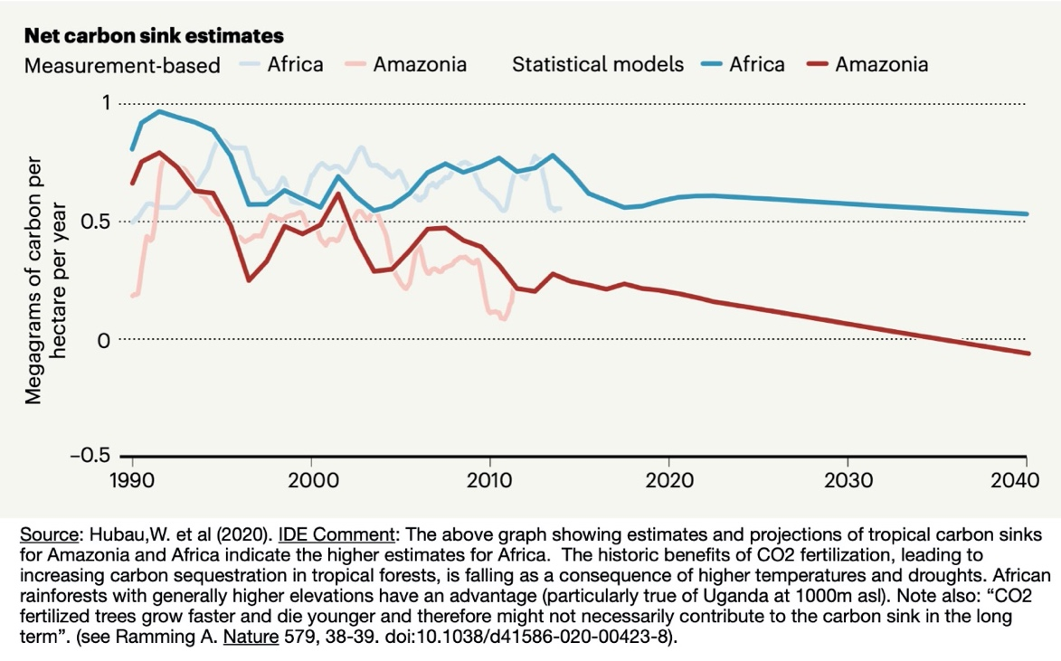
- Martin J.P., Lewis, Simon L., Affum-Baffoe, Kofi et al. (2020). Long-term thermal sensitivity of Earth’s tropical forests. Science v.368, 6493, pp.869-874 DOI:10.1126/science.aaw7578. The research indicates that forest thermal sensitivity is dominated by high daytime temperatures which depresses growth rates and shortens the time that carbon resides in the ecosystem by killing trees under hot dry conditions. The effect of temperature is worse above 32ºC. However, under moderate climate change forest carbon stocks are likely to remain higher. (IDE comment: Uganda’s altitude keeps max. daytime temperatures well below the critical 32ºC protecting forests from high temperature stress for the longer term than Amazonian and Central African rainforests).
- Lake Victoria Basin Commission. (nd) Lake Victoria Basin Climate Change Adaptation Strategies & Action Plan 2018-2023. Pp58. The report distinguishes between the long rains from late March to June (MAMJ) and the short rains from early Oct to Dec (OND). El Niño result in above normal rains, whilst El Niña in below normal rains. These two oscillations (ENSO) have occurred approx. every five years since 1970 but can vary from 2- 7 yrs. Trend analysis shows a long-term decline in precipitation for the long rains (MAMJ) with drier periods getting longer and more pronounced. Trends also indicate total rainfall in the short rains (OND) has increased and modelling suggests this trend is likely to continue.
- Royal Botanic Garden Kew. (2017) State of the World’s Plants 2017. Chap 7 ‘Climate Change: Which Plants will be the Winners?”(pp 42-49). Plant traits are identified which may help with adaptation to temperature and precipitation stress. These include: more sclerophyllous leaves (i.e. lower SLA); higher wood density; more-efficient water-use strategies and deeper roots. (IDE comment: the Mvule tree has at least two of these key plant traits - relatively high wood density and sclerophyllous leaves). For the report see: https://stateoftheworldsplants.com/2017/climate-change.html
- Uganda’s Climatic Advantage for tree planting in a warming climate: The charts below provide additional climate data for a better understanding of why Uganda’s location can provide an advantage in the medium term to tropical moist forests carbon sequestration rates in a warming climate over the Amazon and Congo forest basins.
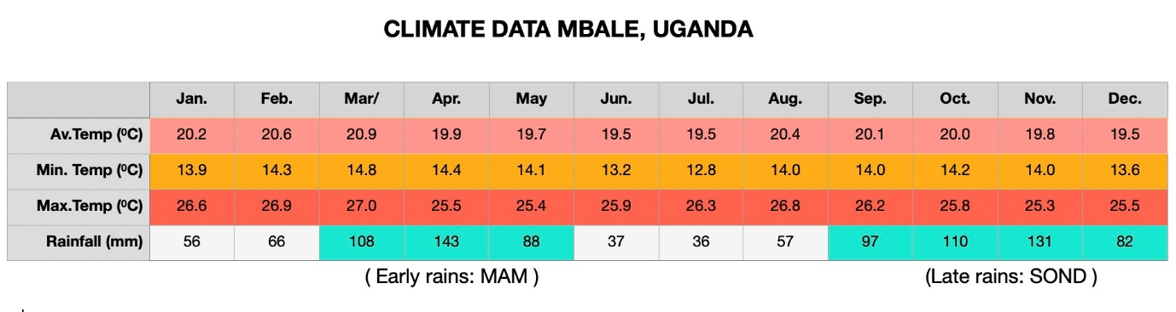
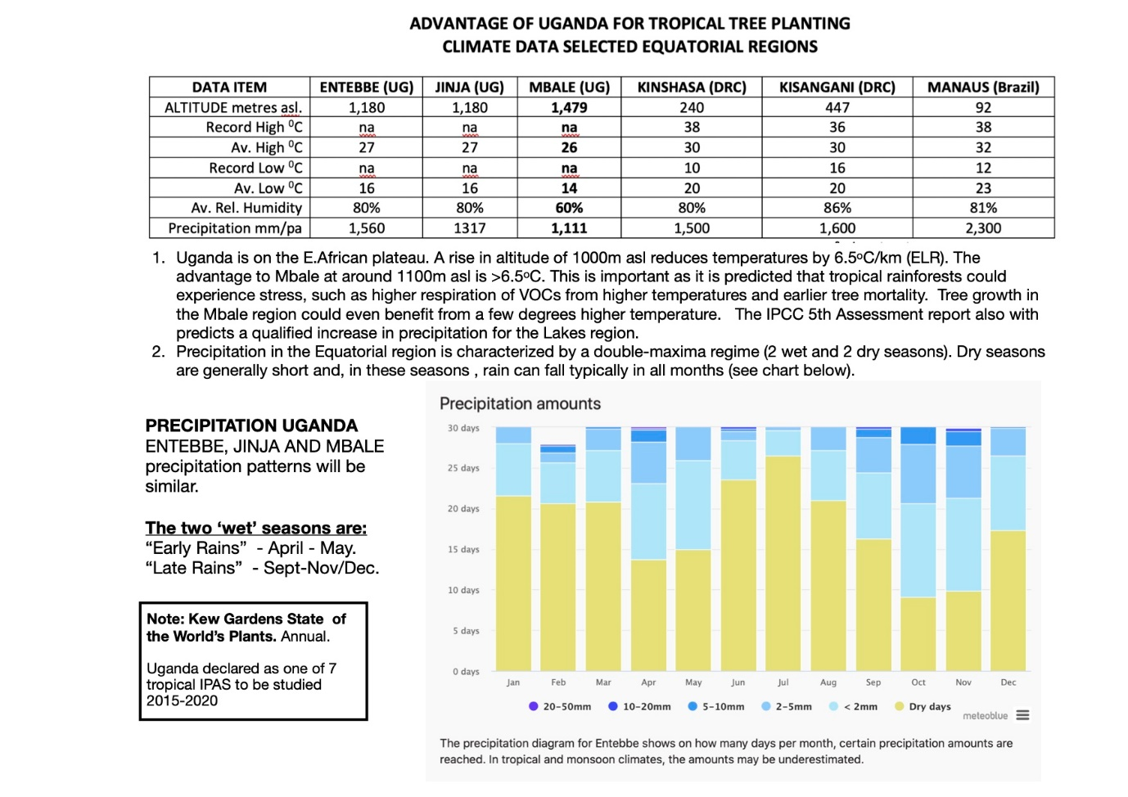
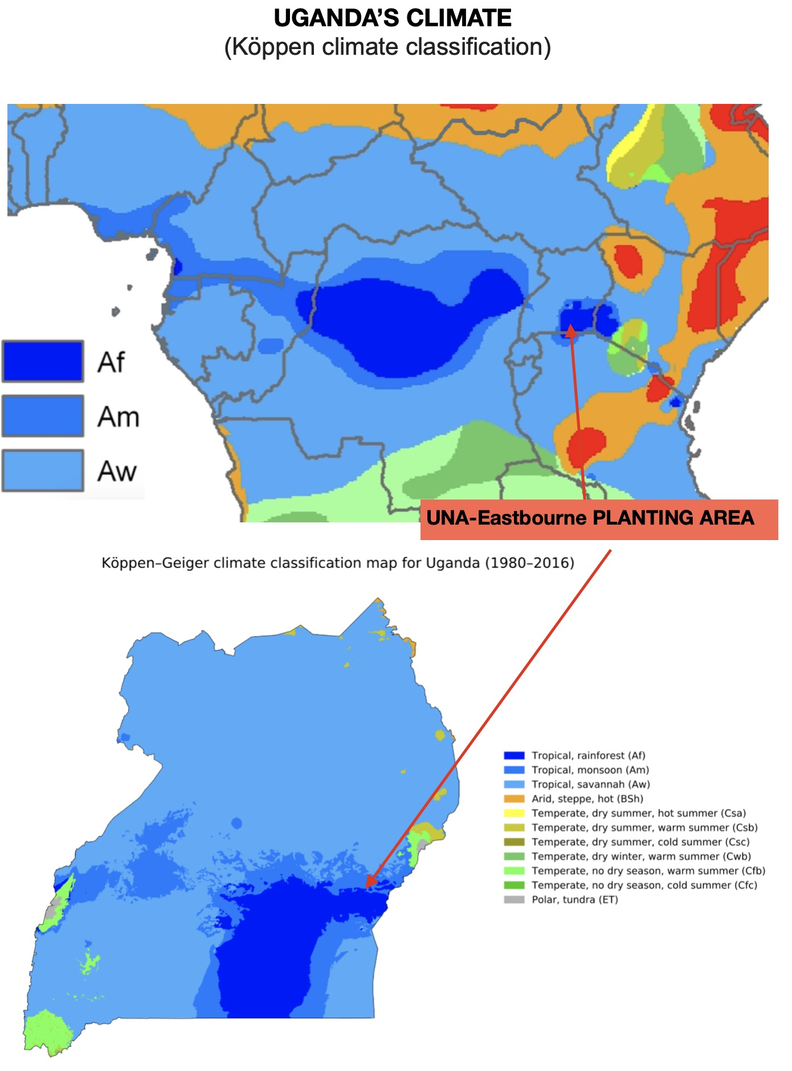
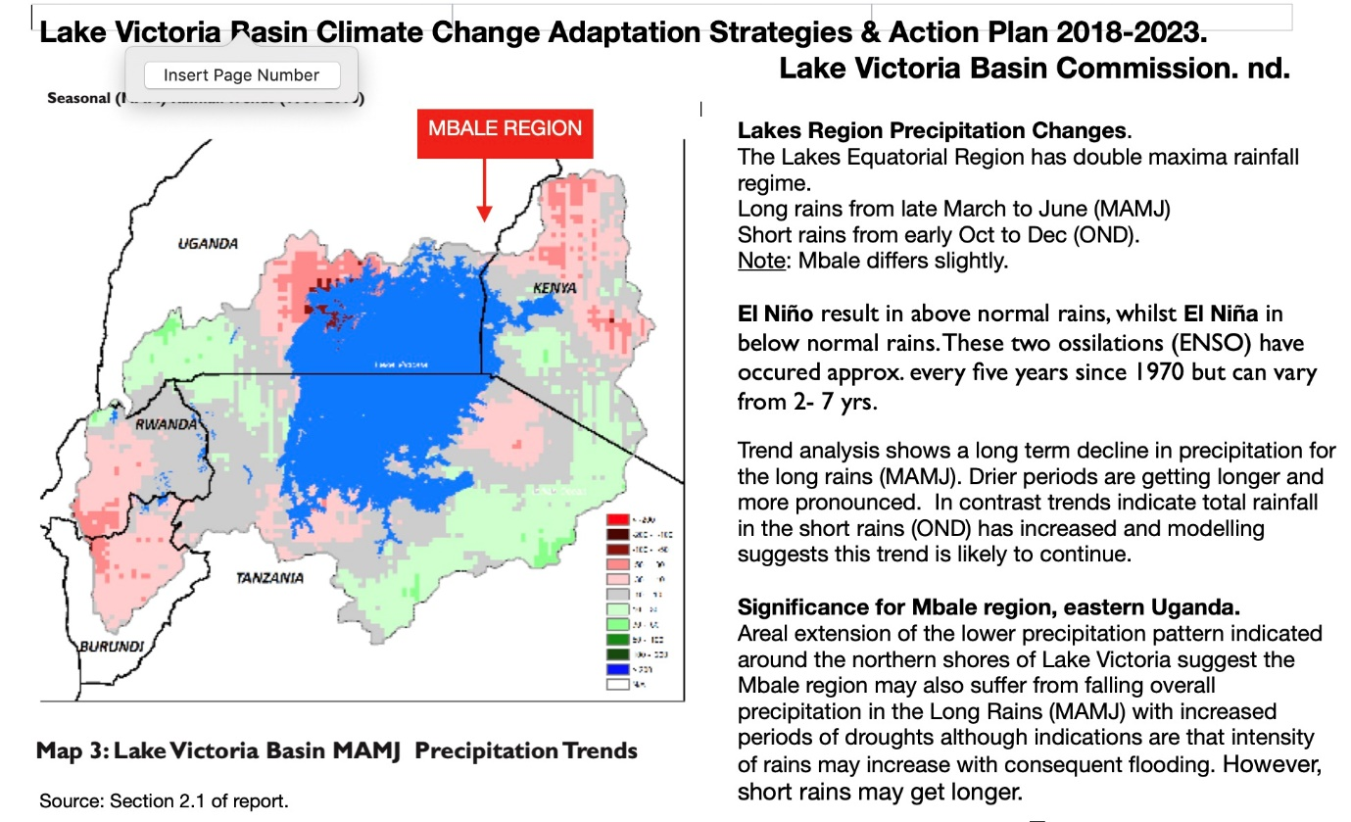

- EVALUATION OF TREE PROJECTS FOR CARBON SEQUESTRATION.

(IDE comment: Tree planting for carbon sequestration is a contentious issue and it is easy to be confused with statements saying “don’t plant trees – trees cause global warming”
- Carton, W., & Andersson, E. (2017). Where Forest Carbon Meets Its Maker: Forestry-Based Offsetting as the Subsumption of Nature. Society and Natural Resources, 30(7), 829–843. https://doi.org 10.1080/08941920.2017.1284291
(IDE Comment: This article refers to the difficulties faced by large well-funded carbon offsetting organisations, in this case, ECOTRUST in Uganda, in partnership with Trees for Global Benefit -TFGB. This paper highlights the difficulties of such large-scale schemes of enlisting local communities with financial incentives for carbon sequestration. Below is an extract from the conclusion of the study, although the full article is recommended reading).
“Under the community-based framework that Ecotrust relies on, the subsumption of nature is effectively outsourced to participating communities and farmers, who assume a stake (and the corresponding risks) in the project by benefitting from instalment payments and the value of the timber. To ensure that tree carbon is sequestered in a way that enables the production of tradeable offsets, farmers are thereby expected to live up to a specific planting, thinning and pruning regime, to keep track of exact land sizes and tree numbers, to combat pests and diseases and to base their involvement in the project on a cost-benefit estimation of tree cultivation compared to a range of alternative land uses. They are, in other words, submitted to a disciplining exercise that enforces the same logic employed in the subsumption of tree carbon, a logic that prescribes utility maximization and the rationalization of tree management for sequestration purposes. To all intents and purposes therefore, they are enlisted as ‘green custodians’ as labourers in the new carbon economy. This is not to say that the project does not bring potential benefits to participants, that it does not contribute to afforestation, or that Ecotrust is to blame for all of the projects’ shortcomings….the management practices of carbon forestry are fundamentally shaped by the requirements of the carbon market, which for all sorts of socio-economic reasons (not least widespread poverty) are often far from the reality on the ground. TFGB participants have their own priorities, time constraints and livelihood concerns that partly conflict with Ecotrust’s ideas about ‘boutique’ offset production. To the extent that this puts them into conflict with the organisation’s objectives, this has led to substantial misunderstandings and frustrations, causing large numbers of farmers to fall short of their contract requirements, with some even removing trees and leaving the project.”
- UNEP (10 Jun 2019) “Carbon offsets are not our get out-of-jail free card”.
UNEP emphasises that projects which offset schemes support are vital: trees must be planted, existing forests and peatlands that hold and absorb carbon must be protected. However, they in themselves are insufficient as they give the dangerous illusion of a “fix” that will allow our billowing emissions to just continue to grow”.

(IDE Comment: This is a point made by Greenpeace UK (20/05/2020) “The biggest problem is that carbon offsetting doesn’t really work”. Such headlines are eye-catching but misleading. The issue, as recognised by UNA Eastbourne, is that planting trees must not be used as an excuse for continuing with our high carbon emissions. Tree planting is essential but must be coordinated with reductions in current carbon emission programmes by all sponsors).

The biggest problem with carbon offsetting is that it doesn’t really work

